**DAY 3 NAME : Vikram nagaraj S**

**ROLL NO : 727721eucs179**

**CLASS EXERCISE 1 :**

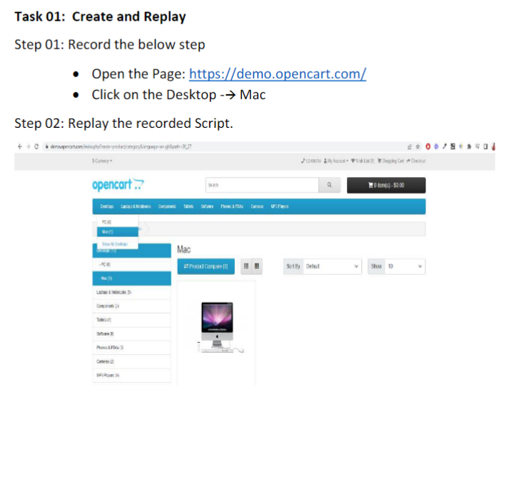

**OUTPUT :**

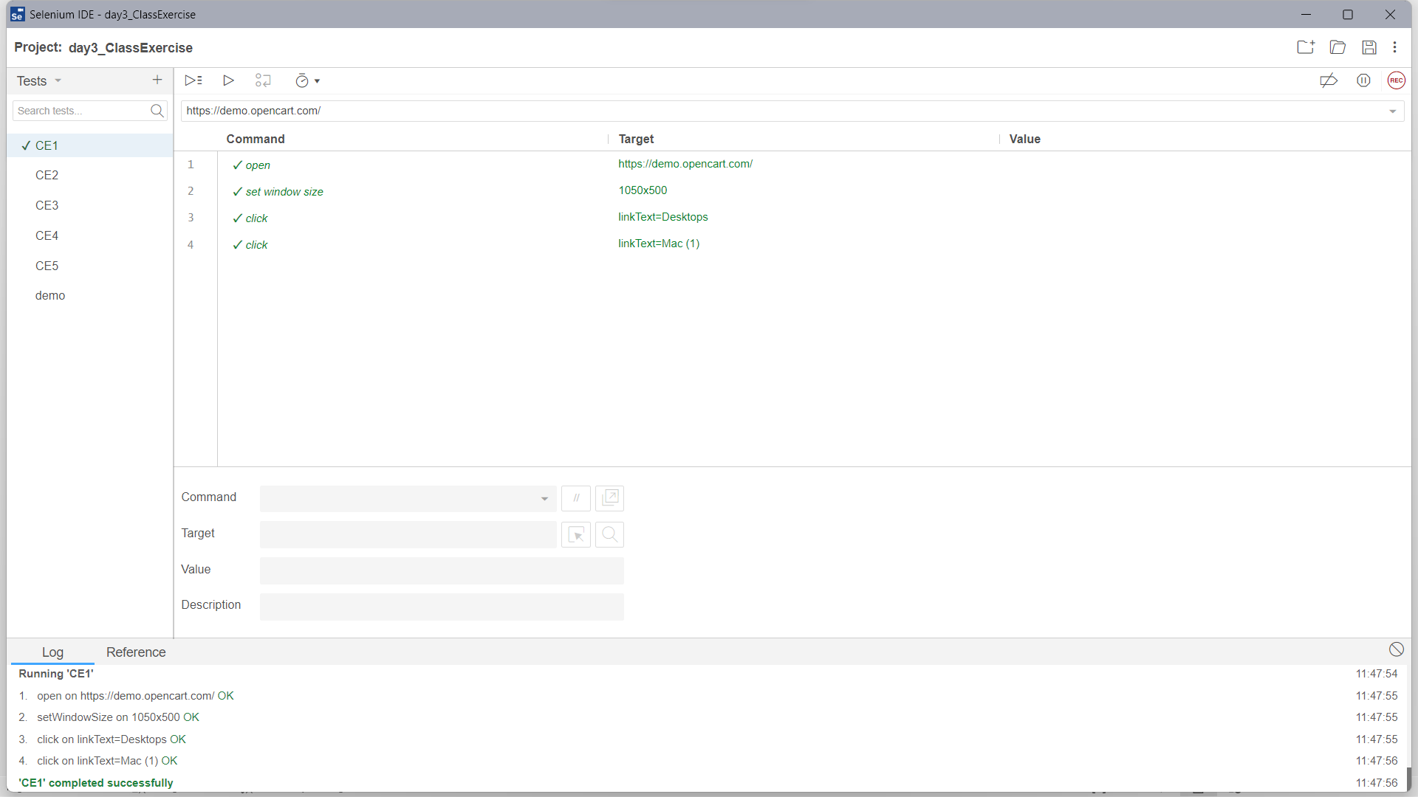

**CLASS EXERCISE 2 :**

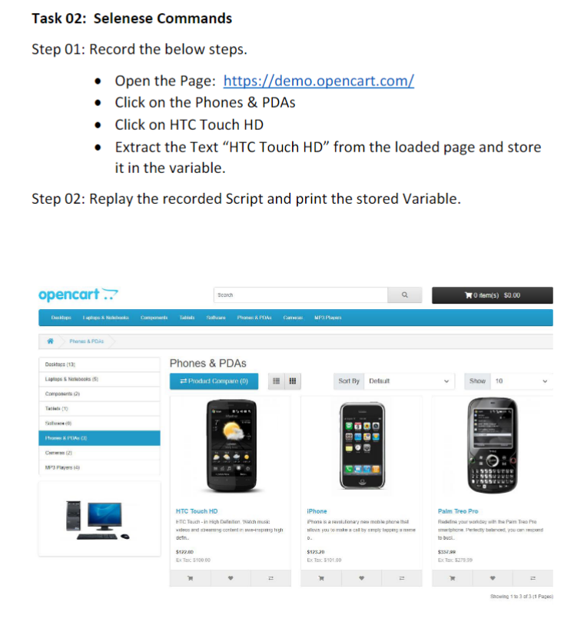

**OUTPUT :**

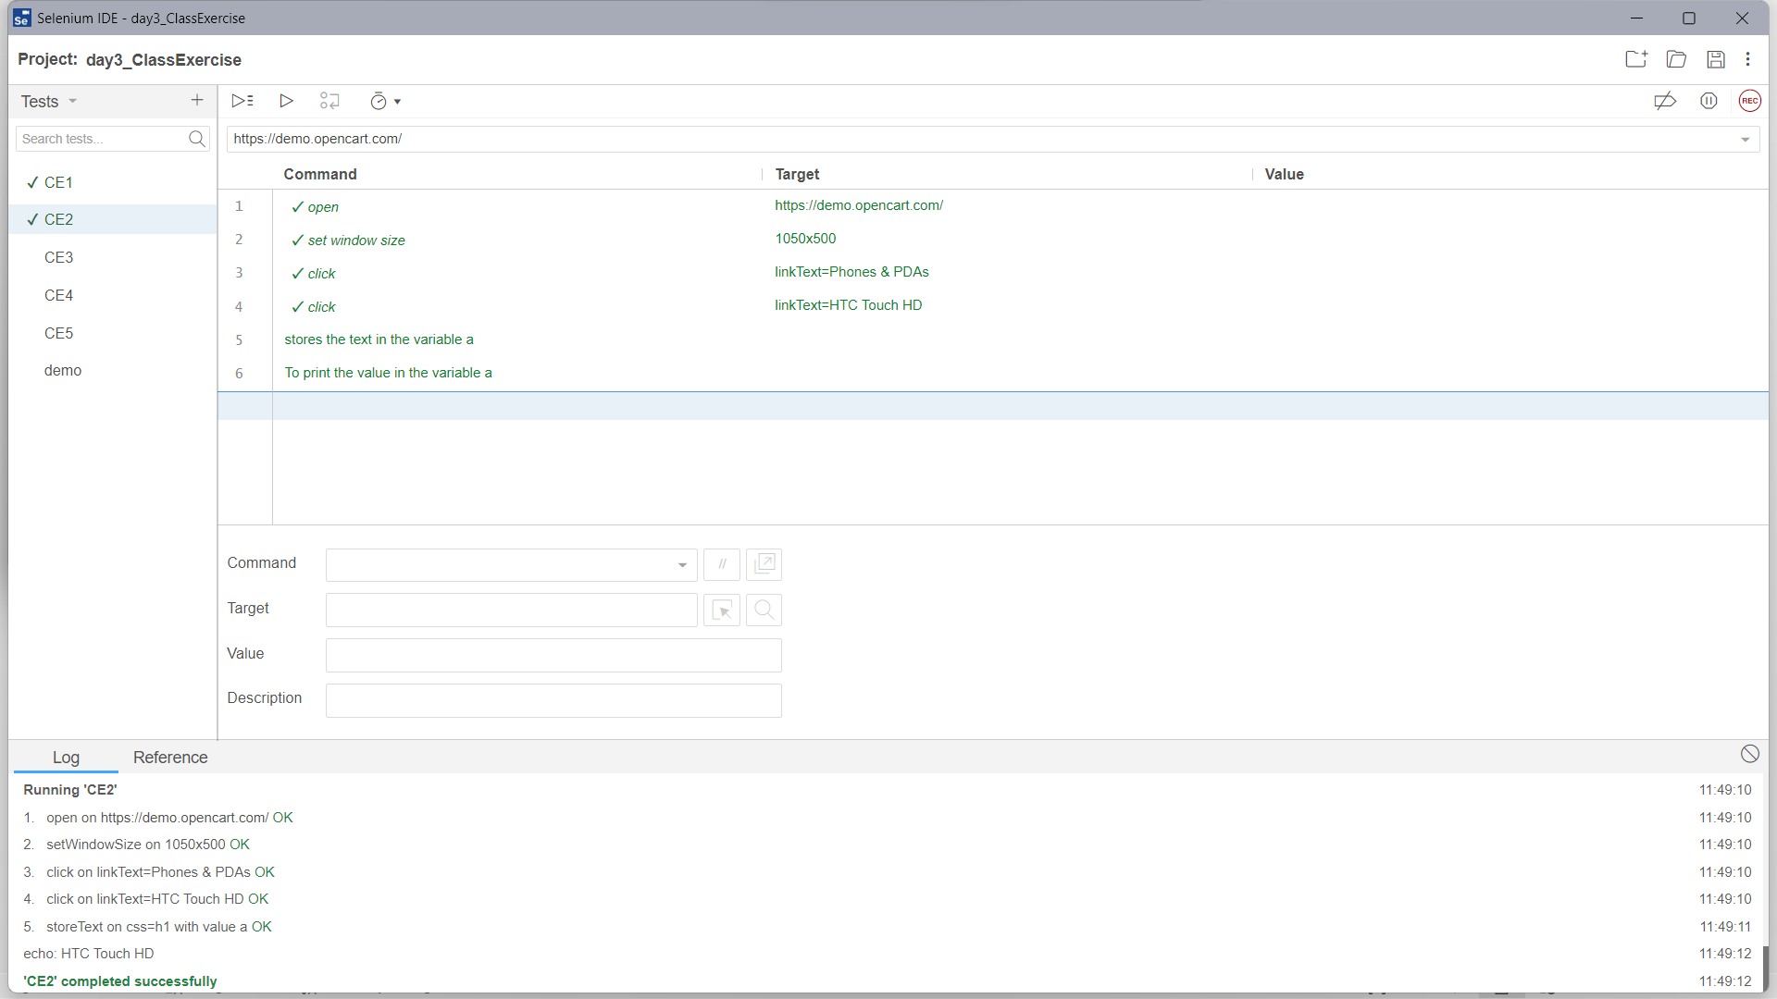

**CLASS EXERCISE 3 :**

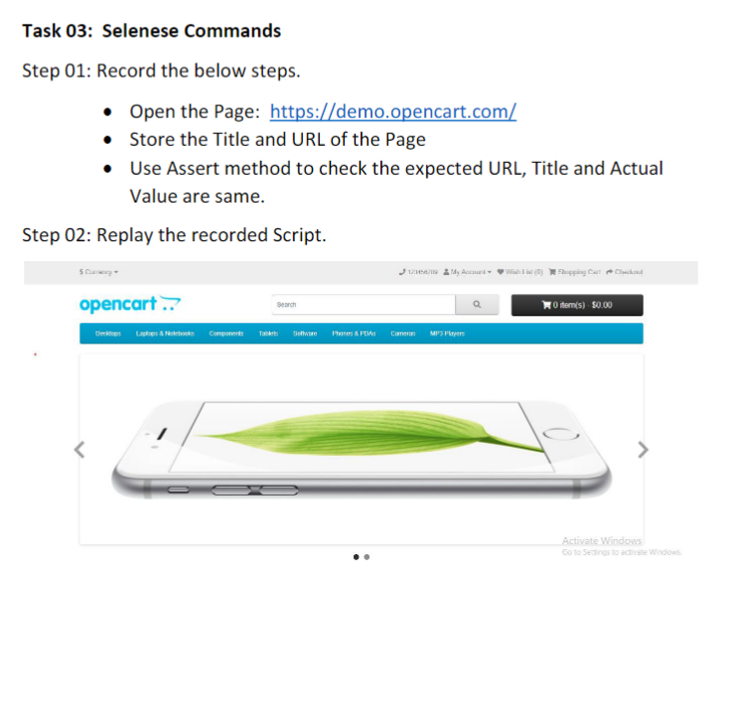

**OUTPUT :**

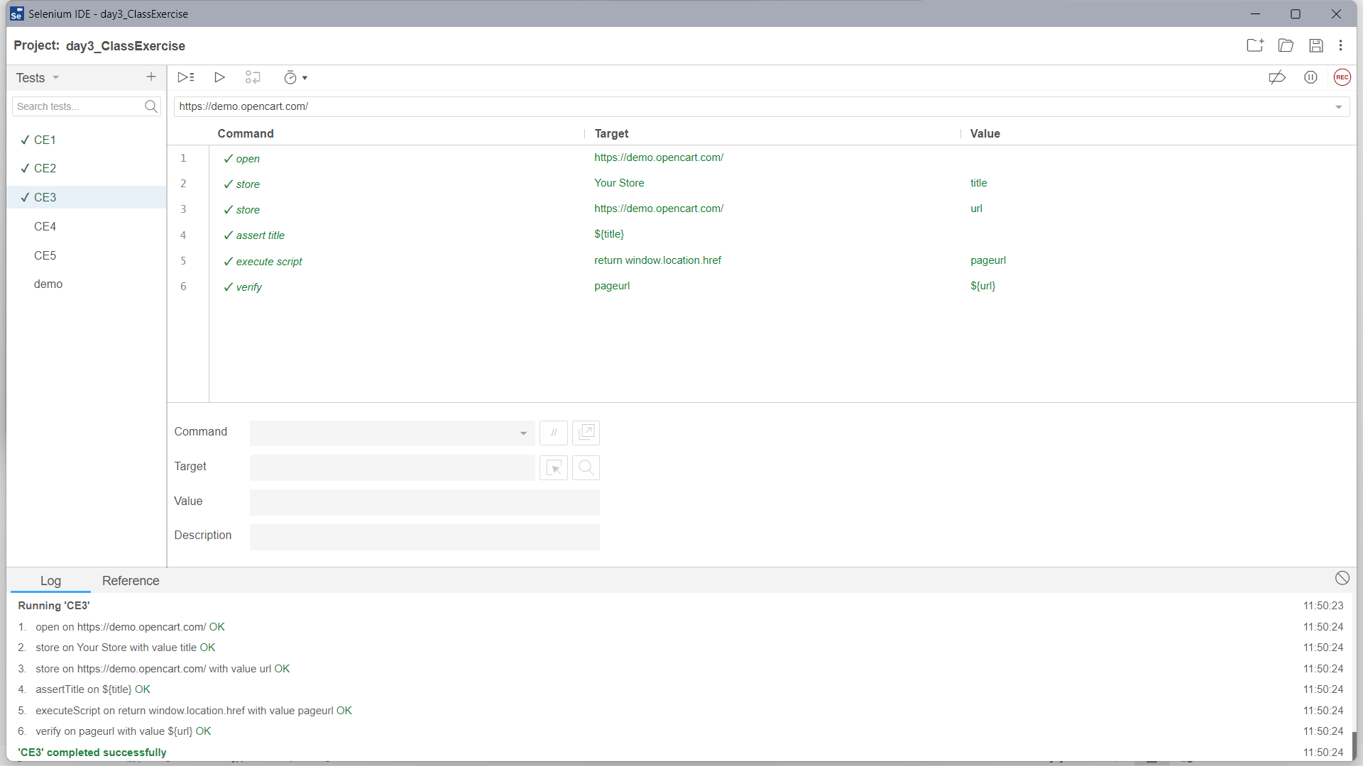

**CLASS EXERCISE 4 :**

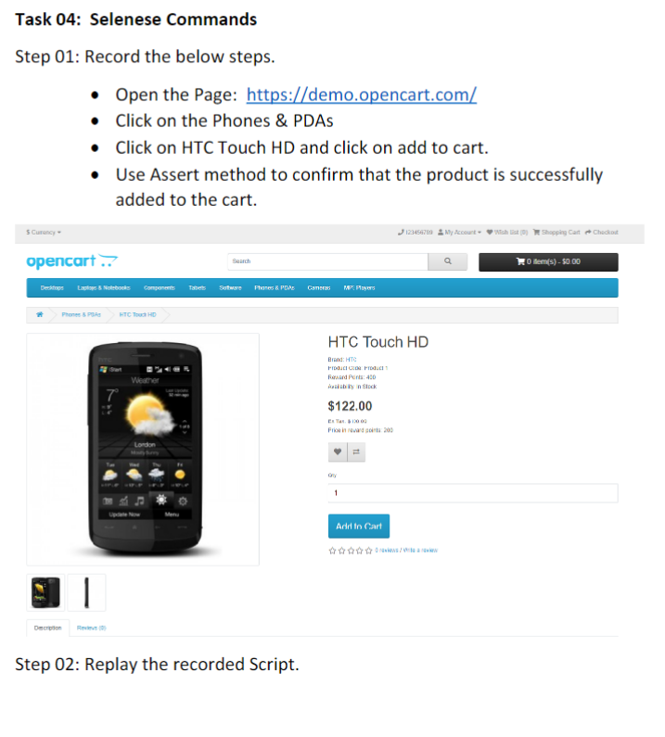

**OUTPUT :**

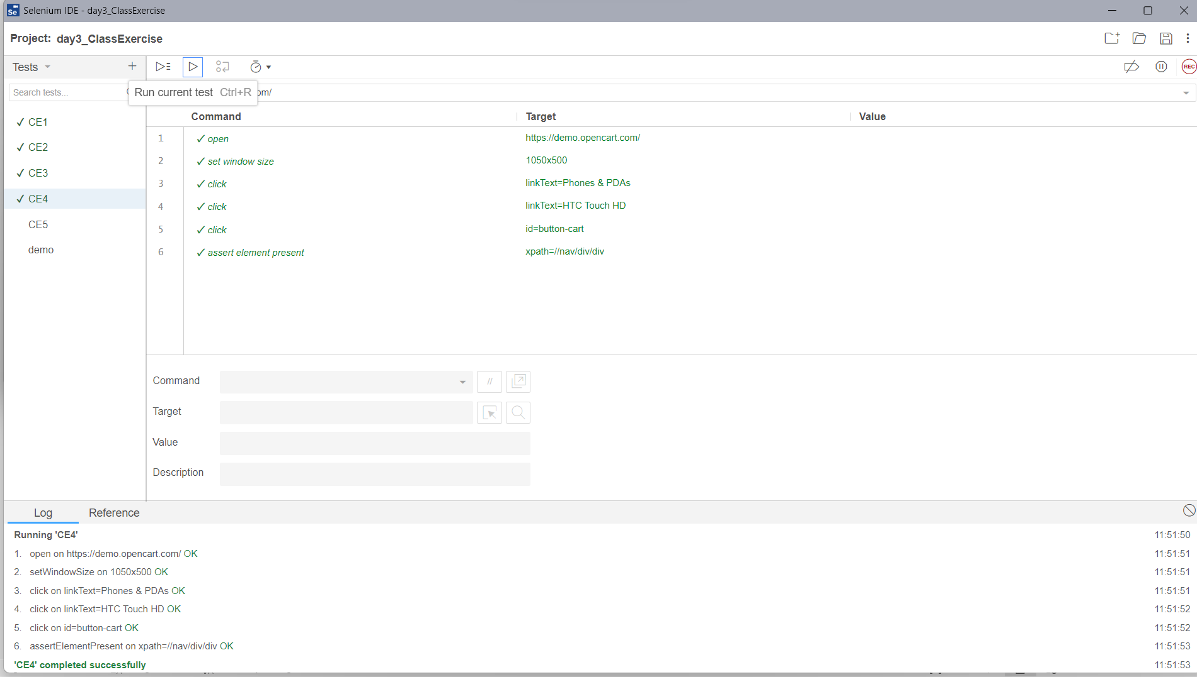

**CLASS EXERCISE 5 :**

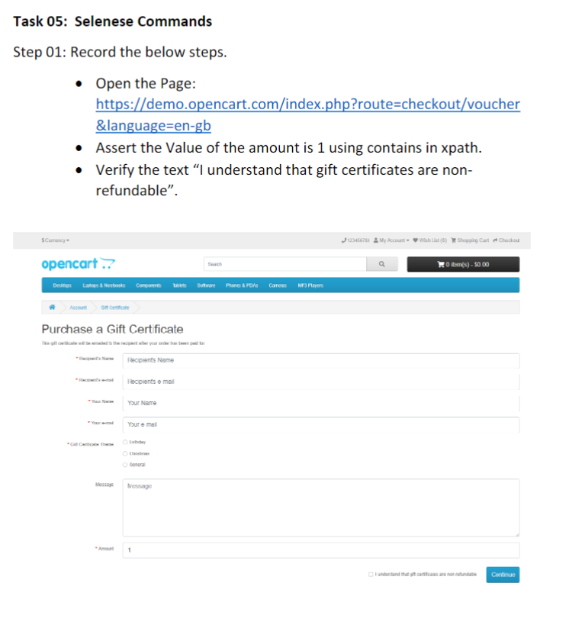

**OUTPUT :**

